**What Is The Best Way To Get Rid Of Computers And IT Equipment?**

The presence of millions of PCs, laptops, and cell phones, as well as IT equipment, adorns landfills. This is not only bad for the environment, but it is also bad for our health. As a result of these sources, certain lung and skin disorders have evolved in recent years. And it's not even slowing down; it's simply getting faster. The true issue is how to properly dispose of computers and other electronic devices so that they do not contribute to e-waste. Clueless? Don't worry; we've come up with a few ways to assist with computer disposal and recycling.

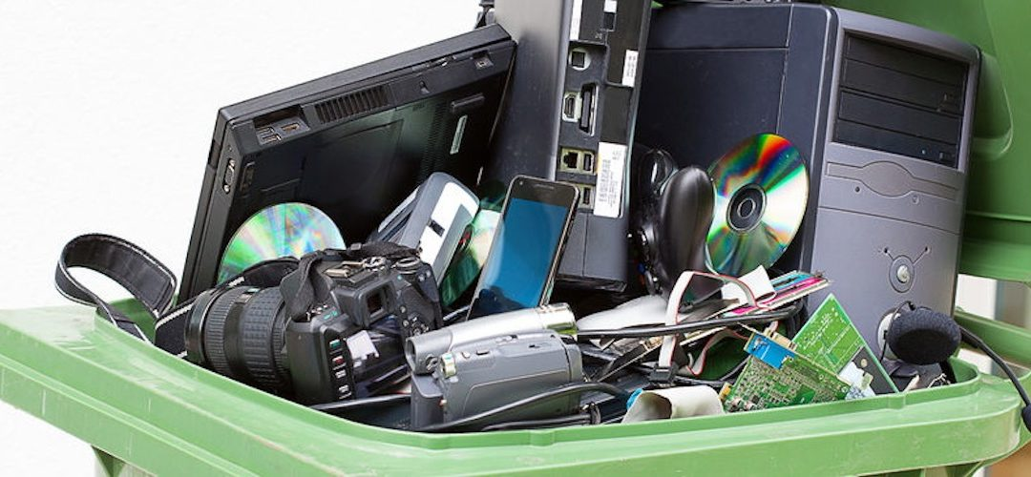

**What Is The Best Way To Get Rid Of Computers?**

Disposing of computers and PCs has become commonplace in recent years. People simply toss out-of-date and antiquated IT equipment in their garbage cans. This is not the proper technique to dispose of plug-in devices with batteries. The appropriate disposal of computers is no laughing matter, and public awareness about the slow poison of e-waste must be raised.

Only by properly disposing of electronic devices can IT recycling and e-waste creation be controlled. IT equipment, such as computers, laptops, printers, cell phones, cameras, and anything else with a battery, must be properly maintained.

Let's look at how to properly dispose of computers.

**Starting from the Ground Up**

First and foremost, make privacy your top priority.

When computers or cellphones are thrown away, they constitute a gold mine for identity thieves. Identity theft is a crime that can be avoided if sensitive information is not left out in the open. It will eventually benefit no one except us by saving us from any serious inconvenience.

We'll walk you through the process of getting rid of your computer equipment, starting with the essentials.

**Computer Disposal Procedures**

A computer is disposed of in three steps:

1. Knowing the hard drive
2. Cleaning the hard drive
3. Disposing of the computer

Let’s get started:

1. **Knowing the hard drive**

Understanding what a hard drive is and what's on it is the first step in computer and IT recycling. A hard disc is similar to a huge trash where data keeps piling up. So, take a moment to recall what you must have saved on your computer. Data stored on a computer is sensitive because it may contain information that you don't want others to see.

Who says only nuclear codes are classified as sensitive data? Whatever is on a person's computer is their personal property, and they are the only ones who may select who has access to it. This can include everything from personal information to social security numbers.

A computer stores all of the information in bits and pieces, but it only gives us one file that we can view by clicking on it. While we may believe that after we delete a folder, the information is no longer accessible, this is not the case. The bits and pieces strewn across the system can be used to reassemble the data you accidentally erased. Only by utilising software that overwrites, corrupts, and wipes files clean can we avoid this.

1. **Cleaning the Hard Drive**

Cleaning the data on the hard disc is the second stage in computer disposal. This procedure will wipe clean any files that are no longer needed. But before you do that, be sure you get the ones you'll need in the future. If you're merely migrating from one PC to another within the same company, for example, you'll need the clients' information. As a result, make sure you save the relevant data on:

* A USB Drive
* An External Hard Drive
* A Portable CD / DVD
* The New PC
* A Cloud Drive

It's now time to clean up the garbage after saving the necessary files. It's not enough to simply delete the files. No, scrubbing the recycle bin clean isn't enough. So, what do we do now?

There are a number of software packages that can clean your data effectively. There are two types of these:

1. The ones that wipe the entire drive and the ones that let you pick and select which files to delete
2. Those who overwrite multiple times and those who only overwrite once

Experts recommend using one that overwrites the drive multiple times rather than one that only does it once. Because the deleted data could otherwise be recovered. Some even recommend physically destroying the hard disc after it has been removed from the computer.

1. **Disposing of the Computer**

It's now time to finally dispose of the computer after wiping the data and any sensitive information from it. If you're unsure how to get rid of computers, consider the following options:

* **Recycling**

Recycling a computer or its parts is the first and most obvious choice for computer disposal. There are a number of organisations dedicated specifically to this goal. They will collect the system from you and recycle it in a variety of ways.

You can always do it yourself if you don't have access to a local recycling organisation. A CPU, for example, can be turned into a fantastic fish tank once all of its internal components have been removed. A motherboard coffee table, on the other hand, would be the main point of a geek lair.

* **Donating**

Is there a better way to dispose of computers than to donate them? Look online or in your neighbourhood for a charity that accepts old and used computers and donates them to others. If you know someone who would benefit from a fully operating computer, consider giving it to them. You can also make a donation to a local orphanage or foster care centre.

* **Reselling**

Many poor organisations and even countries purchase used information technology, particularly computers. Gather information by searching online, asking locally, or visiting your local IT recycling centre. You will be able to obtain the information you require using any of these methods. So, learn how to properly dispose of computers by selling the outdated equipment and get some additional cash.

[IT recycling](https://www.recyclepro.co.uk/) and secure computer disposal are effective ways to protect the environment from pollutants emitted into the atmosphere. It's a terrific way to avoid wasting additional resources, because as the world's population grows, money become scarce, having a significant impact on the environment globally. E-waste can be reused in a variety of ways. Choose an efficient organisation for computer or laptop recycling to assist you in getting rid of your E-waste.